ASSIGNMENT 6

# COMPILER DESIGN LAB

NAME: Parv Gupta

SAP ID: 500105033

Batch 5

WAP to construct LL(1) parser for an expression in C

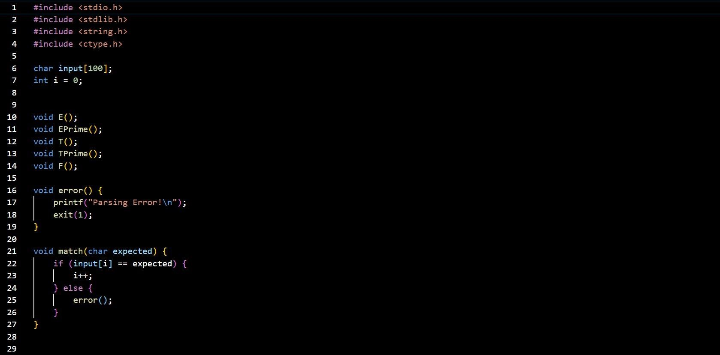

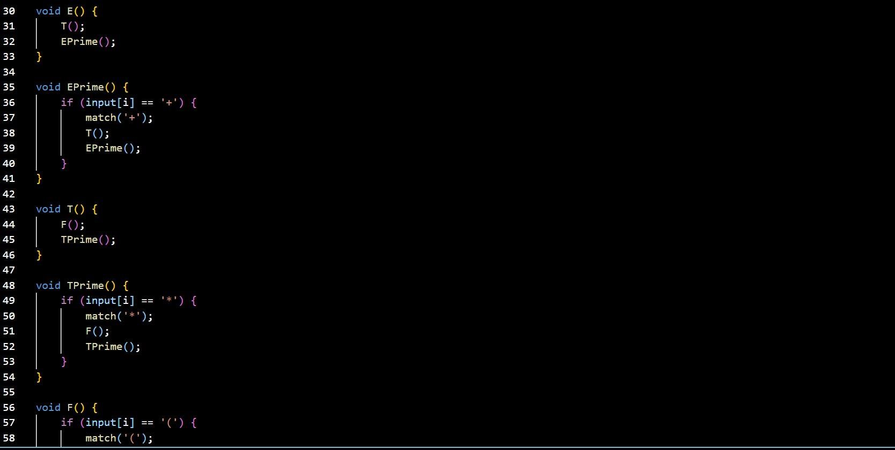



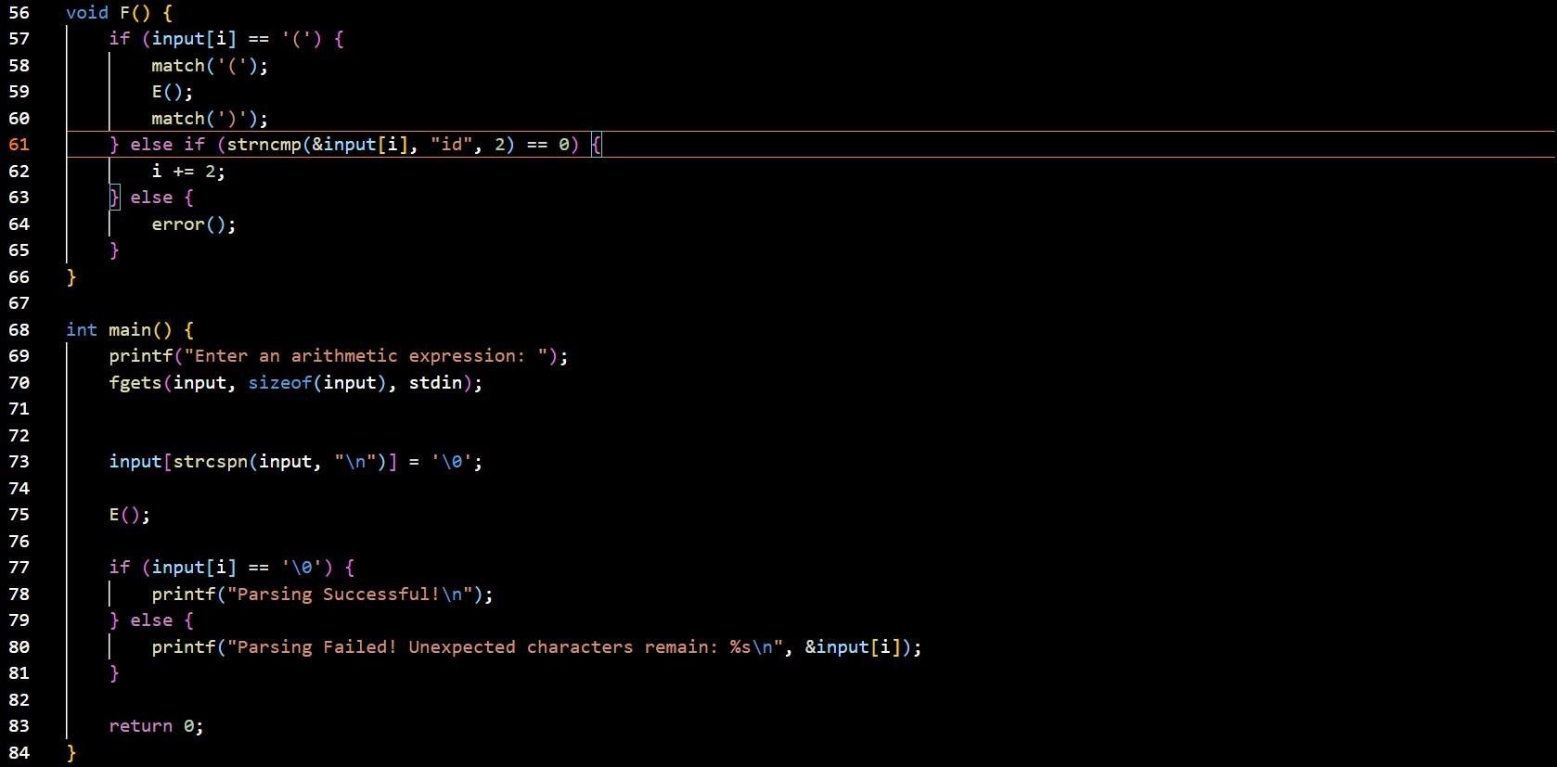

OUTPUT